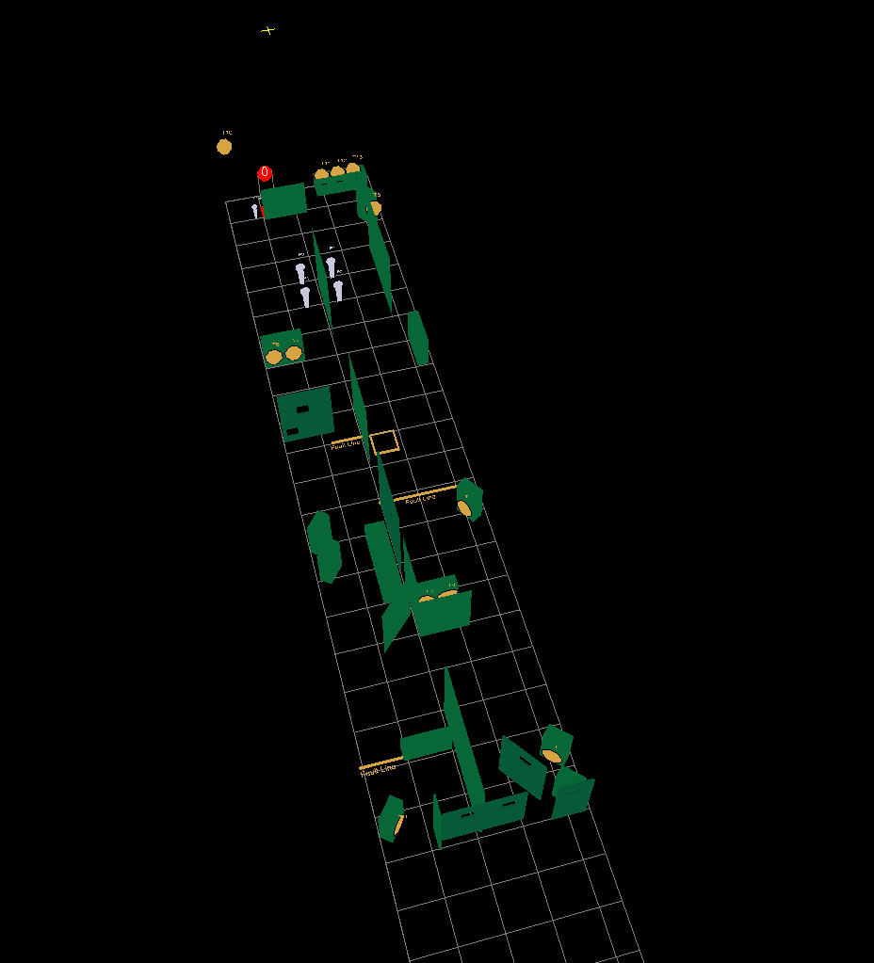
Stage 4. Long Course. Comstock.
13 IPSC paper targets, 4 MPP, 1 plate, some no shoot
Distance: 2 to 25 meter.
Possible points: 155
Min rounds: 31
Start/stop: audible signal/last shot.
Starting position: standing relaxed in box A.
Gun empty in holster.
Procedure: On the start signal engaged all targets free style when they become visible within the designated area. Paper target 9 only with both feet on the bridge.
Note: watch the FAULT-LINES !

