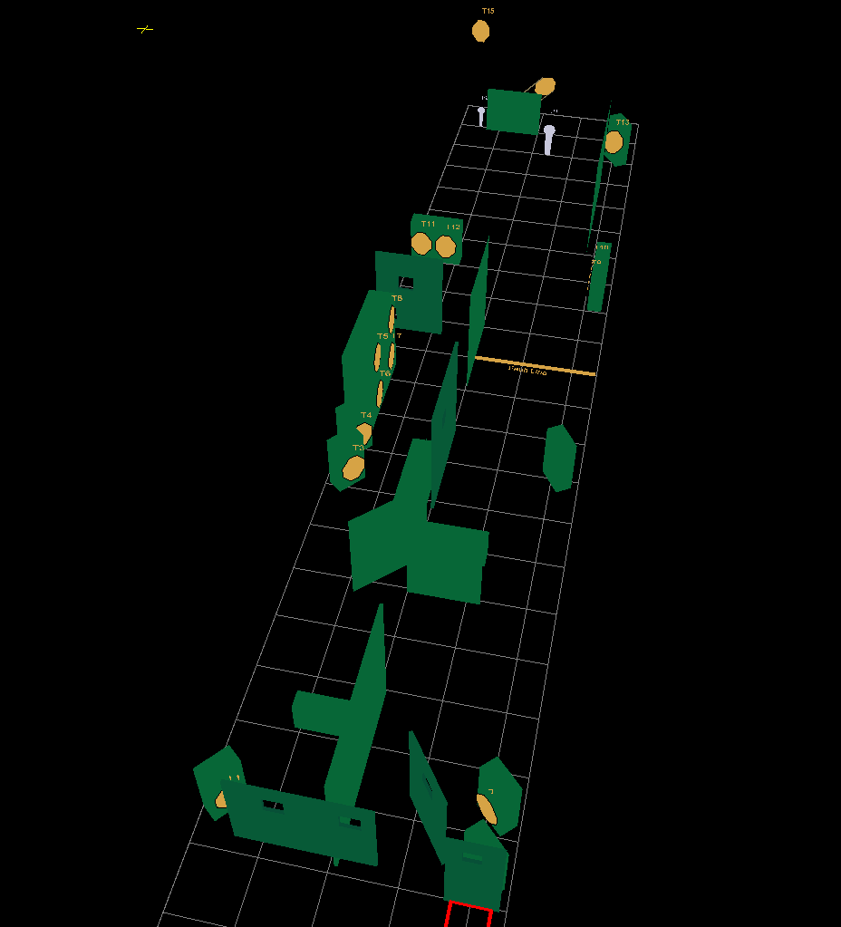
Stage 3. Long Course. Comstock.
15 IPSC paper targets, 1 plate, 1 PP, some no shoot
Distance : 2 to 25 meter
Possible points: 160.
Min rounds: 32.
Start/stop: Audible signal/last shot.
Start position: Standing relaxed on position A.
Both feet on the wall.
Gun ready condition in the holster.
Procedure: on the start signal you shoot the PP mandatory in the starting box.
You can’t shoot him in any other place in the stage.
T7 and T8 strong hand only.
Engage all other targets when they become visible within the designated area. Shooting the plate activated the bobber.

