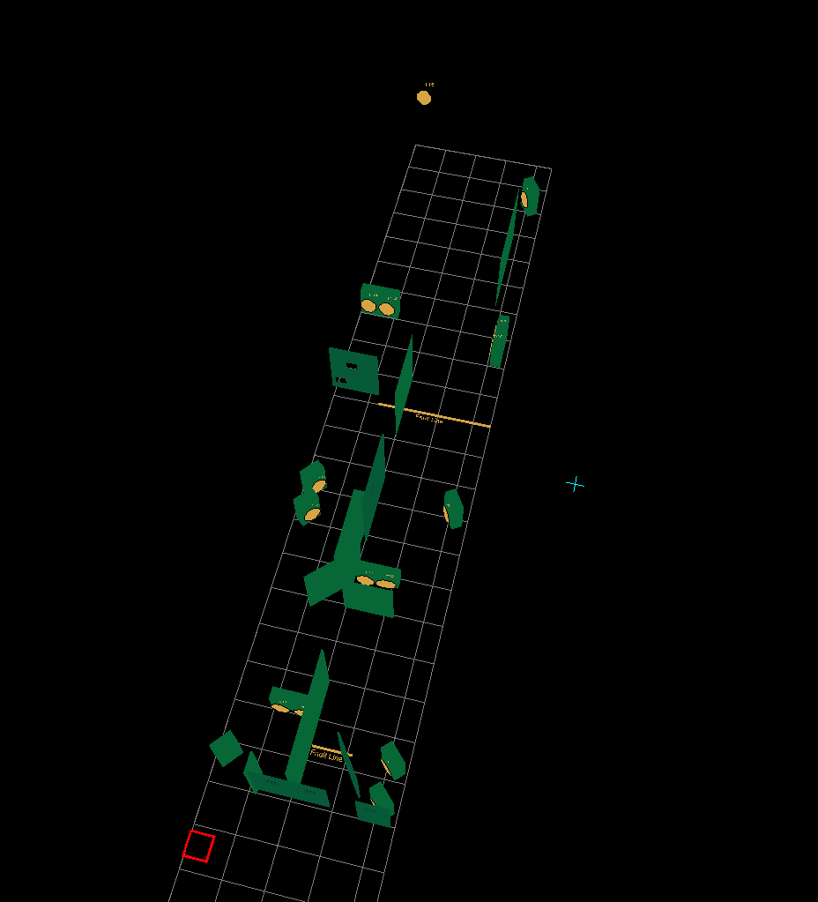
Stage 2
Long course. Comstock.
15 IPSC paper targets.
3 No Shoots.
Distance 2 to 8 meter
Possible points: 150
Min. rounds: 30
Start/stop: audible signal/last shot.
Start position: Hands on the wall. Facing the wall. Gun in ready condition in the holster.
Procedure: On the start signal engage all targets free style, any order, when they become visible within the designated area. Paper targets T 8 , 9, and 10 only with both feet ON the bridge.A fault results in one procedure for each shot .

