Stage 1/4

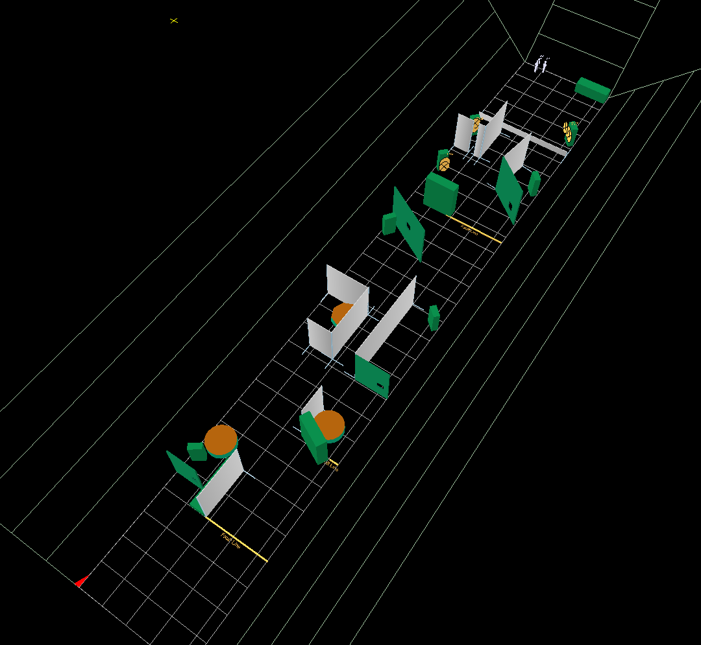
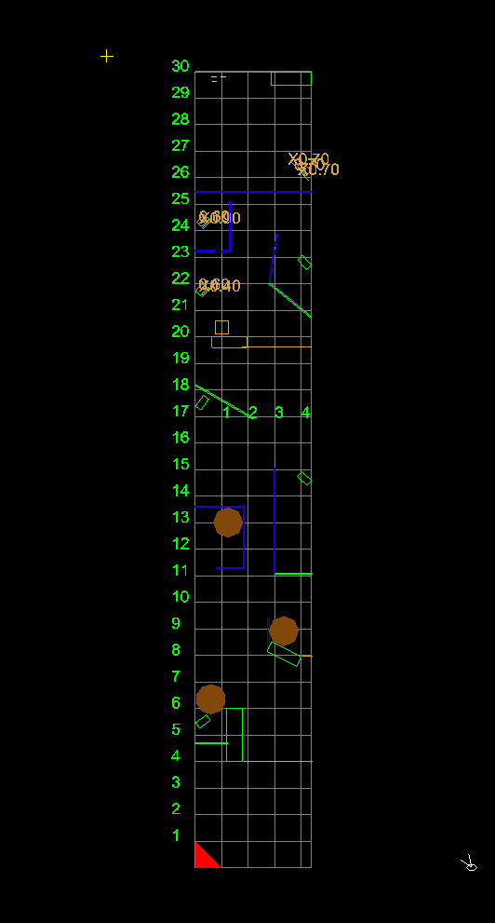
Gostar B.P.S.A.-contest 2008 11the edition
Min. rounds: 103 + 8 chrono
No lead bullets .

Stage Instructions
Stage 1: short Course- Comstock
3 paper targets, 3 mini peppers, 2 penalty targets

Distance: 2 to 8 meters
Possible points: 45
Min rounds: 9
Start/stop: Audible signal – last shot
Start position: Standing relaxed in box A. Gun unloaded in the holster
Procedure: On the start signal engage the 3 mini peppers IN box A. The other targets , when they become visible, in the designated area’s.

Stage 2/4

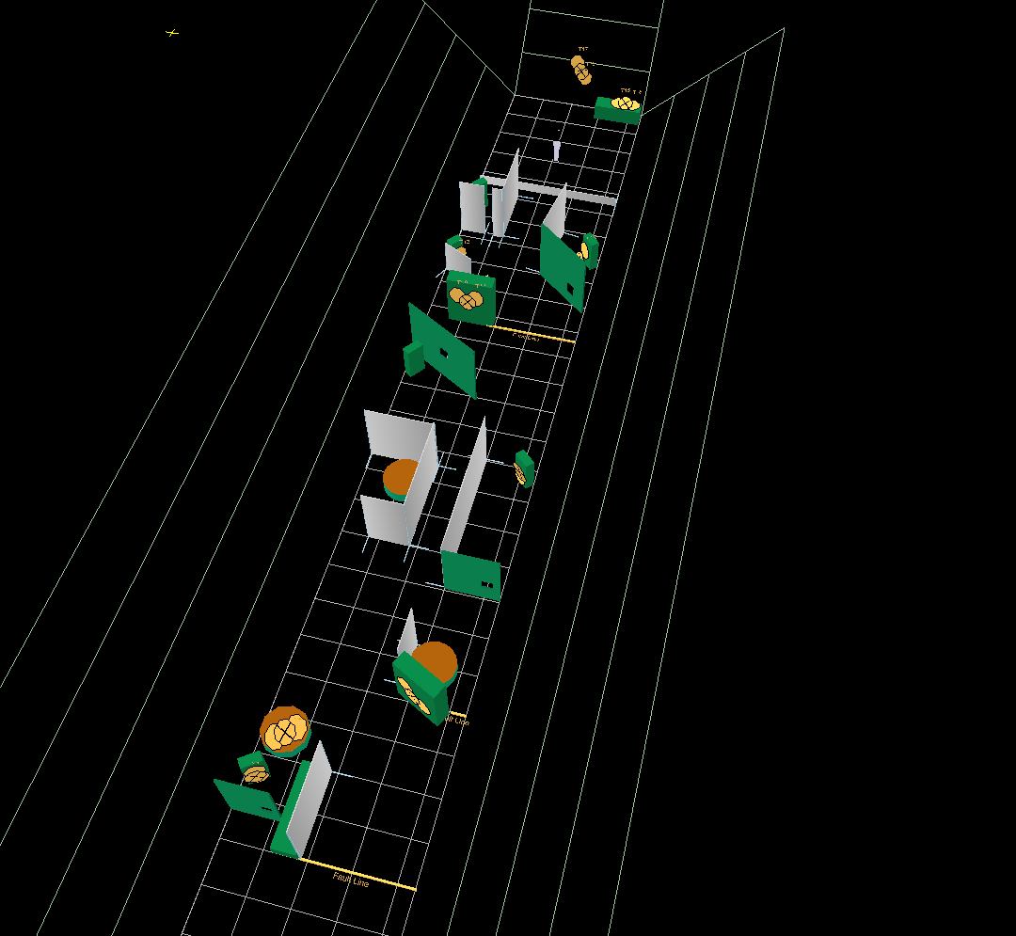
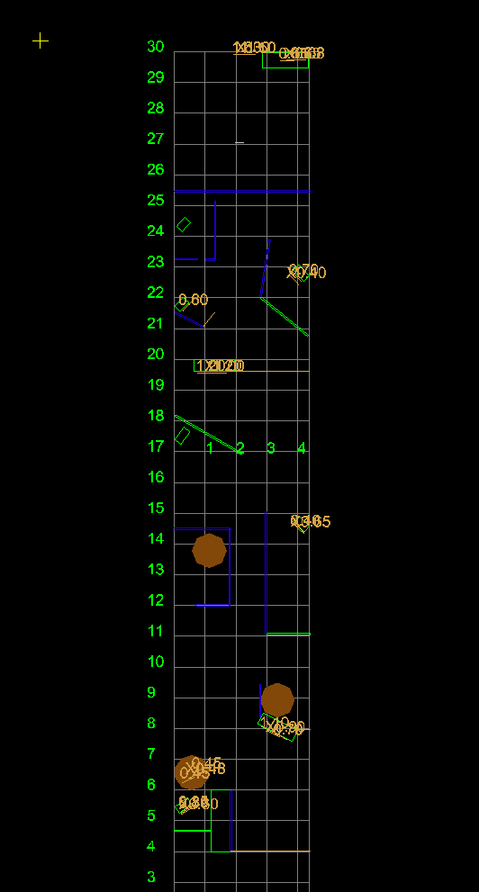
Stage Instructions

Stage 2 :Long Course, Comstock
15 paper targets, 6 penalty targets, 1 classic Pepper

Distance: 1 to 25 meters
Possible points: 155
Min. rounds: 31
Start- stop: audible signal- last shot
Start position: Sitting relaxed on the bike, feets on the feetrests, hands on the handlebars.Gun UNLOADED in the holster.
Procedure : On the start signal engage the pepper AND the paper targets T1 and T2 when you are sitting on the bike. T4,T5,T6 and T7 must be hidden with BOTH feets on the bridge. The other targets when they become visible within the designated area.

Stage 3/4

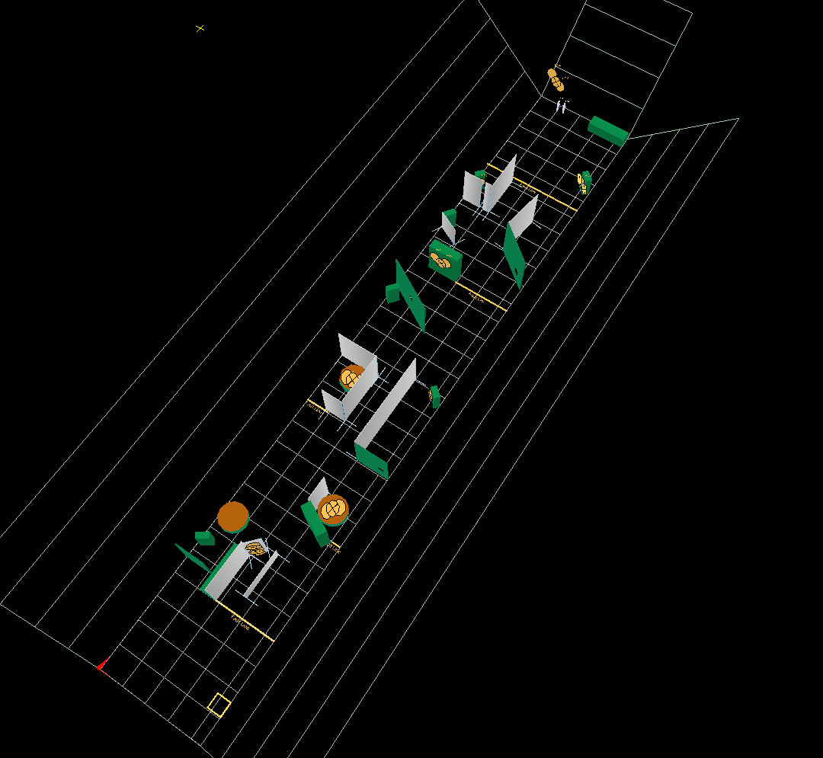
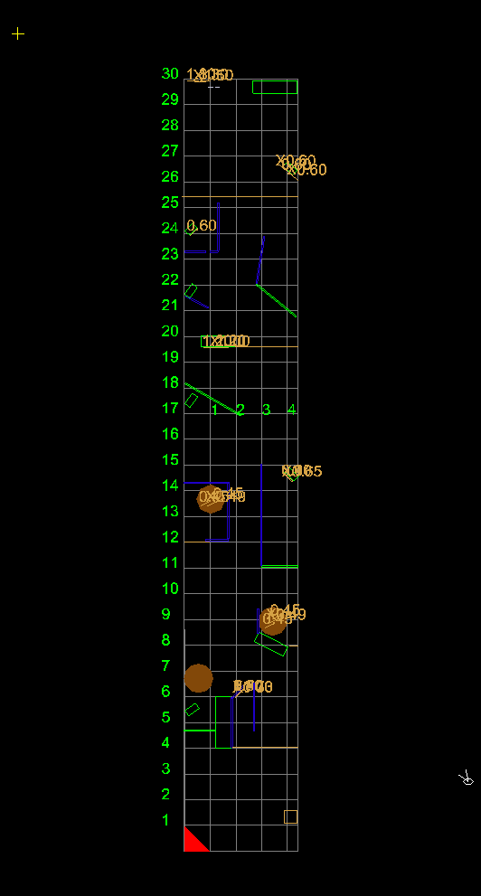
Stage Instructions
Stage 3- Long course- Comstock

15 paper targets, 6 penalty targets, 2 mini peppers

Distance: 1 to 25 meters
Possible points: 160
Min. rounds: 32
Start- Stop: Audible signal – last shot.
Start position: Standing relaxed in the box, facing the wall , hands on the marks on the wall.. Gun in ready condition in the holster.
Procedure: On the start signal engage all targets free style, any order, when they become visible within the designated area.

Stage 4/4

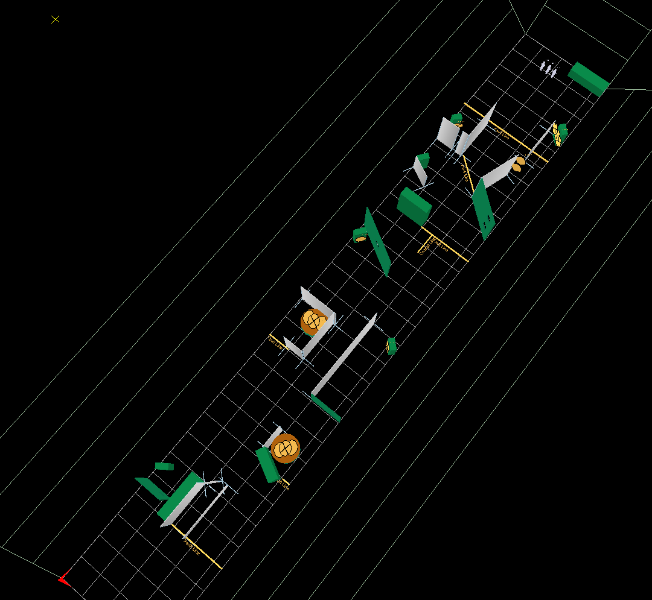
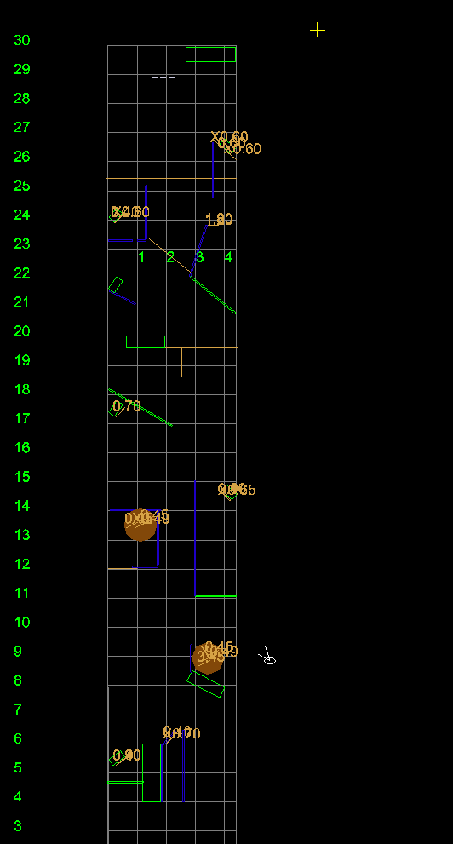
Stage Instructions

Stage 4 – Long Course – Comstock

14 paper targets, 4 penalty targets, 3 mini peppers.

Distance: 2 to 25 meter
Possible points: 155
Min. rounds: 31
Start- Stop: Audible signal – last shot.
Start position: Standing relaxed on position A, one feet on each side of the red line. Gun in ready condition in holster.
Procedure: On the start signal engaged the peppers P,1, 2 and 3 standing in the starting position. The other targets free style, any order, when they become visible within the designated area.

